Appendix A
Matching Game Terms

Species Composition

The different species represented in a
biological community

Species Abundance

The number of members of a species
existing in a specific location

Evergreen

A plant that retains green leaves
throughout the year

Temperate

A region or climate characterized
by mild temperatures

Decomposition

The state or process of rotting; decay

Microclimate

The climate of a very small or restricted area, especially when it is different from the surrounding areas

Ecosystem

A biological community of interacting
organisms and their physical environment

Succession

Predictable and orderly changes in the
composition or structure of an ecological
community

Biodiversity

Variation in life; can be genetic or within
species or ecosystems

Conifer

A tree where seeds are produced inside of cones

Disturbance

An event that occurs quickly and creates a
significant change in an ecosystem

Old Growth

The final, most stable stage of a forest
ecosystem

Forest Floor

The lowest layer in a mature forest; consists of
decaying plant matter and decomposers

Understory

The middle layer in a mature forest; consists of plant life that does not breach the upper layer of the forest
Canopy

The top layer of mature forests; consists of tree crowns and the organisms that live there

Photosynthesis

The process by which green plants and some
other organisms use sunlight to synthesize foods
from carbon dioxide and water

Appendix B
Field Journal
Each student will receive a small journal with approximately 10 pages to use to make observations throughout the day. Students will be able to use information collected in the journal for the worksheet at the end of the day and will also be able to take them home after the trip.

Questions you will ask during the day to prompt journal usage:
Station One: The Tree Climb
- List the three layers of the forest.

Station Two: Karin Rita Gastreich’s Studio
- What do a scientist and an author have in common?

Section Three: Life after Death
- List the 3 layers in the cross section of a tree

Station Four: Naming and Knowing
- List 3 tree species that live in the H.J. Andrews forest.
- (students will also be writing down plant characteristics during this station)

Appendix C
Sticker
Appendix D
Gastreich’s Forest Story

(Revised from Karin Rita Gastreich’s Journal):

“I am hiking through the beautiful forest of the Cascade Range and I realize that whether I enter the forest as a biologist or as an author, the challenge remains the same. I wonder, how can I capture this world and communicate its magnificence to others? I was asked to study the forest from a writer’s perspective from HJA, and I’ve found that my approach to studying the forest as an author is the same as a biologist:

I stop. And then I ‘listen.’ With all my senses.

And I write.

A poem.
She pressed her hands against the rough bark,
closed her eyes and heard the pulse of the tree,
solid and slow, a steady current that stretched
toward the sky and descended into the deepest
places of the earth, a quiet murmur of
indomitable strength.

I think to myself, it is not an easy task to listen, and it is also hard to listen to creatures who speak in a different language. But when I ‘listen’ to the forest, I notice the way the moss hangs from the branches or covers the logs.
The chill of the air.
The shape of the fungi.
The flow of the river.
The hushed sway of the canopy in the breeze.
The rhythmic chirp of a small bird,
and the ‘plasticky crunkle,’ of my rain coat as I write my observations.
‘Plasticky crunkle,’ neither word can be found in the dictionary, but it is what I hear, so I write it down.
I hear the ‘swoosh’ of the trees, and the ‘peckling’ of a Pileated Woodpecker in the tree across the forest, so I write it down.
I write sounds for what I hear, I draw what I see, and I write words for what I feel.

Appendix E
Stages of Decomposition

Stage 1: No moss, bark is still present, wood is clear may have slight blue tint.

Stage 2: An increase in decay, bark becomes damaged; heartwood stays healthy, sapwood begins to decay.

Stage 3: Log itself begins to decay into bark and stubbed branches, wood becomes damaged.

Stage 4: Almost all bark is no longer visible, can no longer support own weight, sapwood is no longer present and heartwood begins to crumble

Stage 5: Log no longer exists in the log shape, begins to turn into a powder where you can see the outline of the decaying matter.
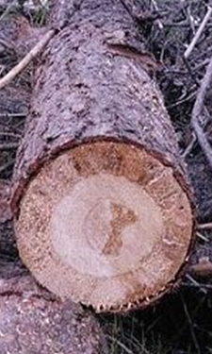
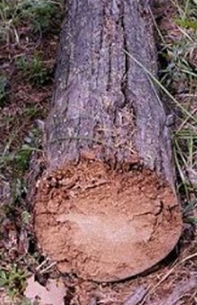
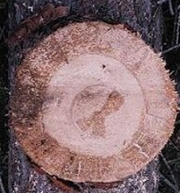

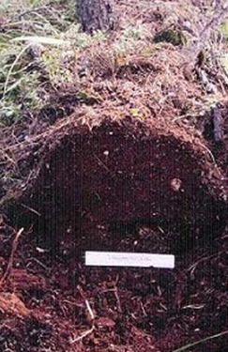

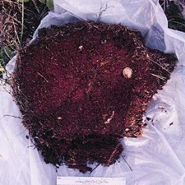

Appendix F
Two Truths and a Lie Cards

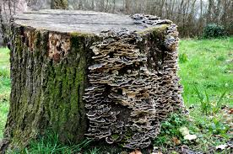
Fungi
Hint: Live in all different types of habitats and grow where there is decaying organic matter to be consumed.
- There are many species of my kind, I can be autotrophic and heterotrophic depending on the type of fungus I am.
- My favorite spot to live is along/on trees.
- I do not contribute to the decomposition process.

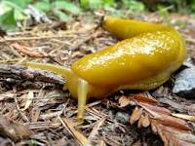
Banana Slug
Hint: Prefer lowland areas of high moisture/plant decay. Live on consuming plant material, mushrooms, animal feces, etc.
1) I am autotrophic.
2) I have thin skin and I produce a mucus to help me keep cool
3) I am sensitive to dry climates, as they affect the moisture content of my skin

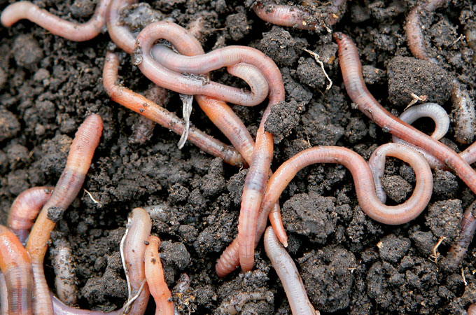
Earthworm
Hint: I live in soils of high moisture content, where I burrow deep beneath the soils eating plant matter, castings, or decaying animals.
- I am heterotrophic.
- I can live in dry soils, without causing too much harm to my body
- I help in breaking down organic matter that increases nutrient content in soils

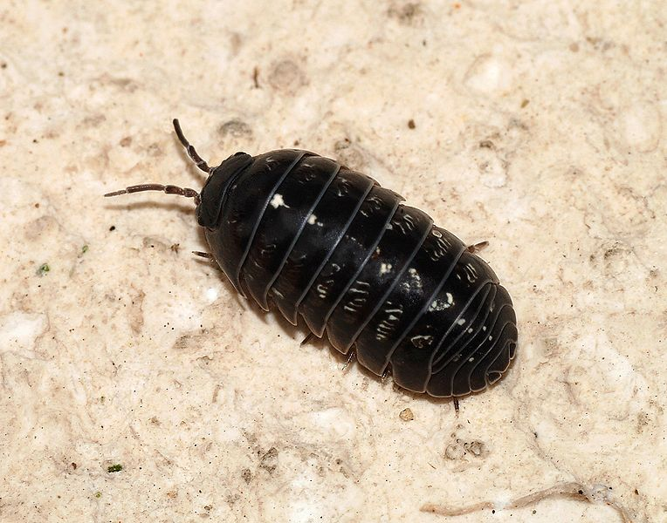
Woodlouse
Hint: You can find me within a pile of leaves or in dead bark, I am usually found in areas of high moisture. I am considered a crustacean.
- I am an insect.
- I am heterotrophic
- I play a role in the natural carbon cycle due to my ability to consume dead organic matter.

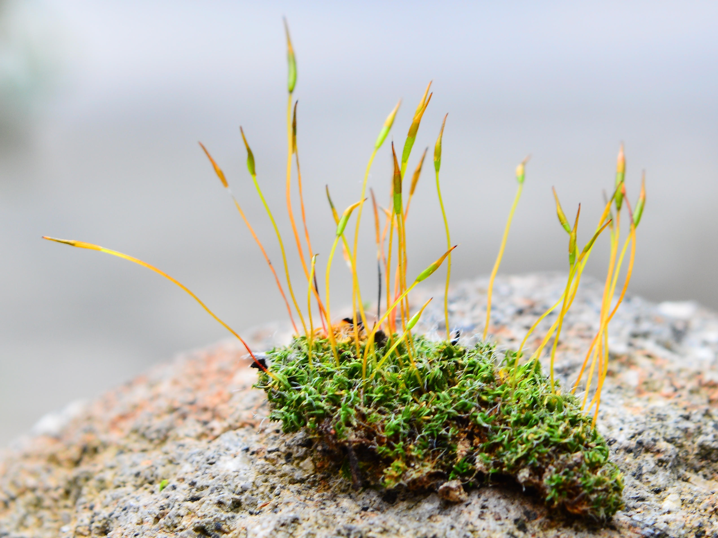
Moss
Hint: I grow in clumps, and will never have the opportunity to flower. I spend most of my time in moist habitats that provide significant amounts of shade, however I can grow in dry climates as well.
- I am considered autotrophic.
- I feed off of organic matter from nearby soils
- There are many different species of my type.
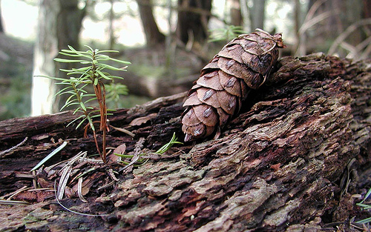
Douglas fir
Hint: I am a tree whose sapling can grow from a dead tree. I am considered Oregon’s state tree, and keep my green throughout the year. I can be found in coastal climates as well as rocky slopes, as long as I prefer soils that can drain fast but provide moisture as well.
- I help the decomposition process by absorbing nutrients from organic matter
- I am autotrophic.
- You can find me in areas with other Douglas fir trees

Appendix G
Species Cards
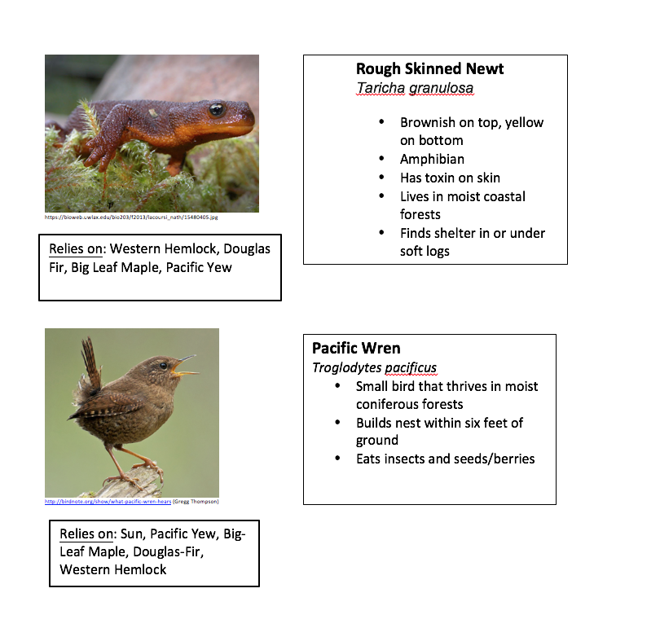

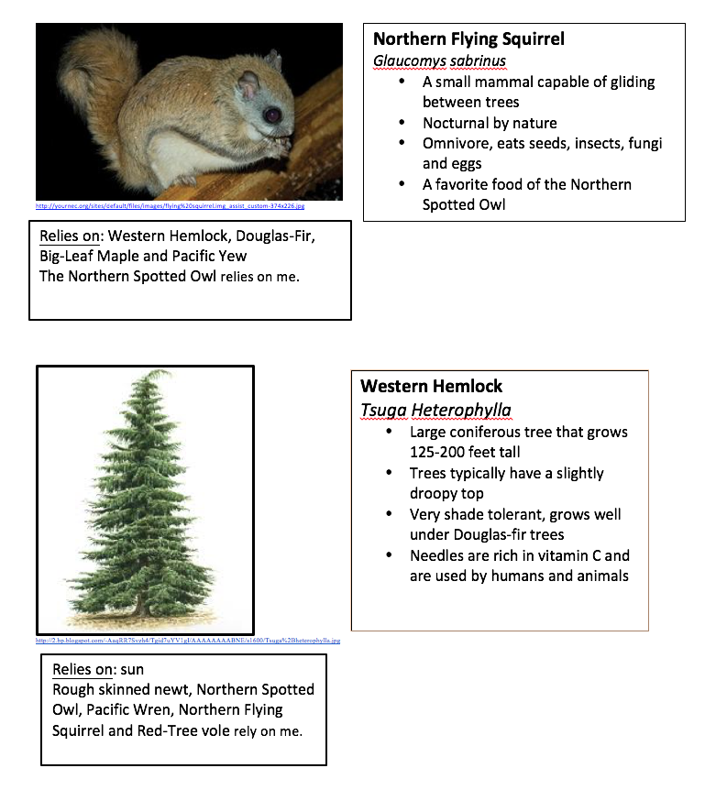
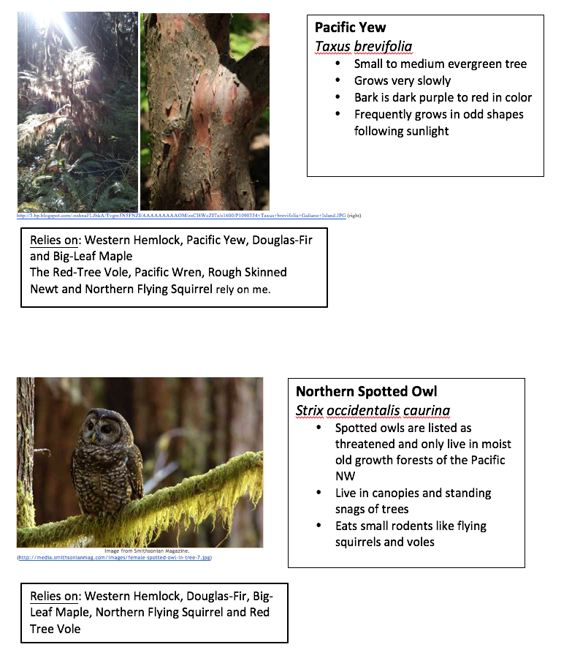
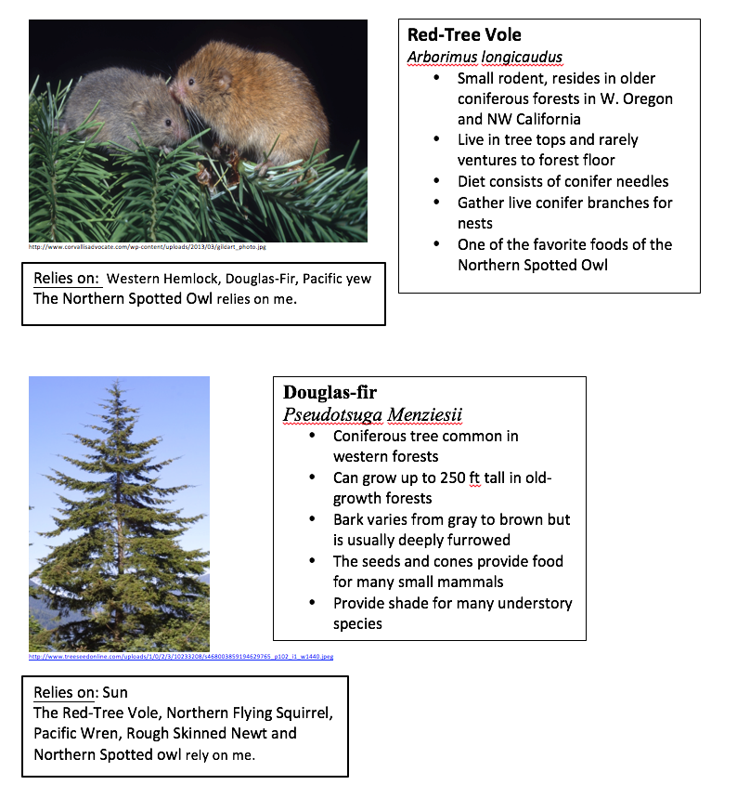

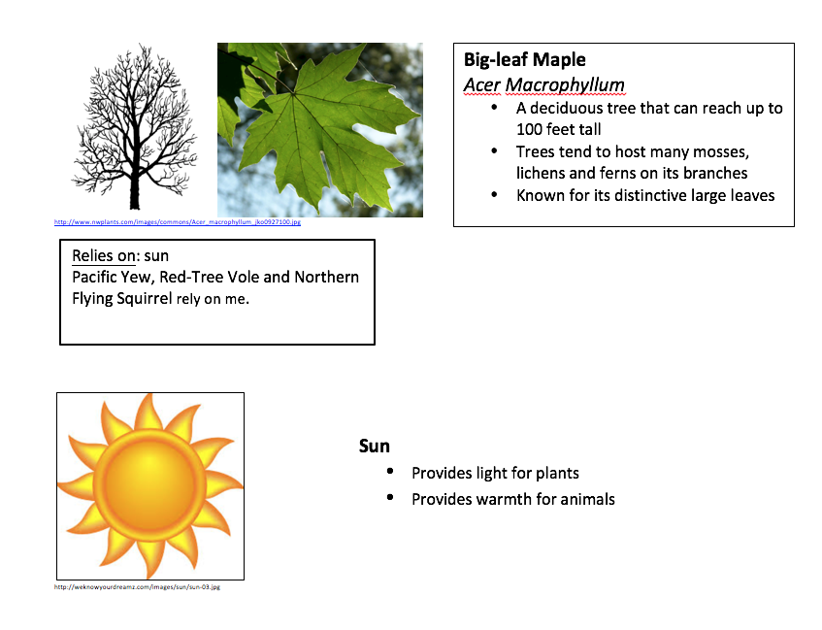

Appendix H
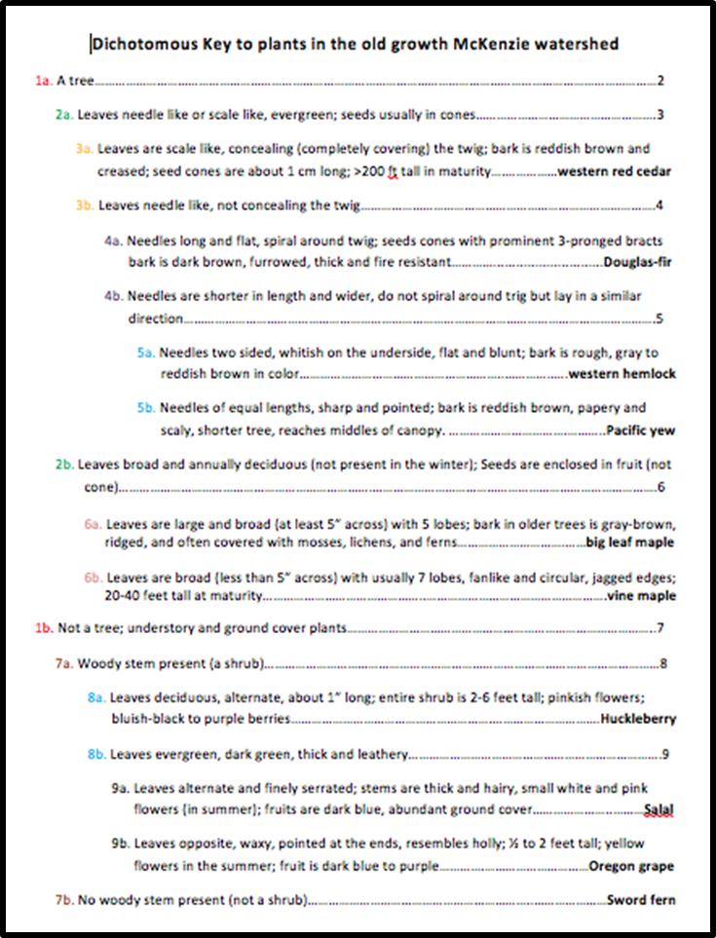
Dichotomous Key

